Anastasia Harouse, Abby Torbatian, and Nancy Xiao

Applied Classification Project
Churn is a critical issue in service delivery, applicable to many contexts from policy to business. Churn occurs when a client discontinues services. In this project, we are identifying which clients will churn for the upcoming school year for Scholastic Travel Company, meaning that they will not book a trip. If we can identify customers likely to churn, we can create strategies to prevent churn and determine how to increase customer retention.

We compare three models for churn classification: K-Nearest Neighbors, Random Forest Classifier, and Gaussian Process Classification. Our outcome of interest is whether a customer will churn. Churn is identified as a binary outcome variable, derived from the RetainedLabel column (1=if churn, 0 if retained). For each model, we perform feature selection differently, and we will discuss the feature selection process in each section.

Across all models, we evaluate each using accuracy, precision, recall, and AUC. For a binary classification, these metrics are appropriate because they capture different aspects of model performance. Accuracy tells us the number of correct predictions we made out of all predictions, giving us a broad understanding of our performance. Precision shows the percentage of churn predictions that are correct. This is important when there is a cost of a false positive, such as an additional intervention. Recall is the number of churn predictions that were correctly predicted, indicating how many churners we are actually capturing. Finally, AUC evaluates the model’s ability to distinguish between churners and non-churners across all possible classification thresholds. Together, we can gain a comprehensive understanding of how well our model is performing.

Data preparation
After searching for missing data, we did not identify any missing points. We converted the following columns into datetime objects so they could be used accurately in prediction: "DepartureDate", "ReturnDate", "DepositDate", "EarlyRPL", "LatestRPL", "InitialSystemDate", "FirstMeeting", "LastMeeting”. From these datetime objects, we derived several temporal features to capture the timeline of student engagement. By calculating the number of days between key milestones, such as the planning_window and meeting_span, we transformed calendar dates into behavioral metrics.

KNN-Model
The first KNN model used the following features as predictors: ToGrade, Tuition, Days, TotalSchoolEnrollment, with k=20. This model serves as a baseline model for future improvements. It reported an accuracy of 71%, a precision of 76%, a recall of 45%, and an AUC of 80.3%.

After implementing the Basic Model, we retained only numeric features since KNN relies on distance-based calculations that require numerical inputs. Features were scaled using StandardScaler to prevent variables with larger magnitudes from dominating the distance computation. N_neighbors = 20 was still maintained. PCA was then applied to retain 95% of the variance, reducing noise and dimensionality. This improved performance to 72% accuracy, 78% precision, 46% recall, and an AUC of 80.6%.

To optimize the model, we used RandomizedSearchCV to simultaneously tune the preprocessing and classifier hyperparameters, including the PCA variance threshold, the number of neighbors, and the distance metric. By evaluating 50 random configurations using 5-fold cross-validation, we identified an optimal setup for this model: Manhattan distance with 64 neighbors, which yielded an ROC-AUC of 81.76%. This hyperparameter tuning significantly improved the model's reliability, increasing precision to 81% and reducing false alarms while maintaining stable predictive performance. Accuracy was 71%, and recall was 43%.

Then, we transitioned from PCA to a manual feature selection strategy, utilizing Mutual Information scores to identify the 10 numeric variables with the highest predictive power for churn. This ensured the model focused only on the most statistically relevant drivers, such as student engagement metrics and financial indicators. We implemented a randomized grid search to further optimize the hyperparameters chosen for the model. This resulted in a model with: 'knn__metric': 'euclidean', 'knn__n_neighbors': 47, 'knn__weights': 'uniform’. This resulted in a model with an accuracy of 77%, a precision of 76%, a recall of 66%, and an AUC of 82.0%.
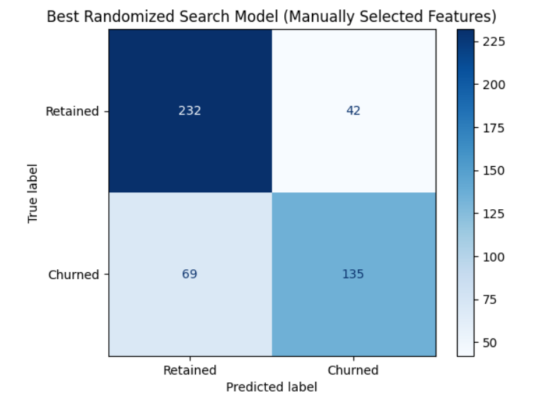
Finally, I attempted a GridSearch (not randomized) to investigate the solutions more systematically. However, that did not improve performance. The AUC decreased from 81.9% to 81.7%, but the precision, accuracy, and recall remained the same. This indicates the KNN Model's best performance.

Overall, by shifting focus from broad dimensionality reduction to the top 10 most statistically relevant drivers, the KNN model achieved its best performance. This final configuration balanced precision and recall, resulting in an accuracy of 77% and a recall of 66%. This marks a substantial improvement in the model’s ability to identify clients likely to churn without sacrificing overall reliability. However, compared to the other models evaluated in this report, KNN underperformed, particularly in recall. A recall of 66% means that the model identified only 66% of all actual churners. For intervention strategy design, a higher recall would be preferable to better target clients at risk of churn.

Iteration | Feature Strategy | Optimization? | Hyperpareameter | Accuracy | Precision | Recall | AUC
1. Basic Baseline | All numeric; Scaling | None | k=20, Uniform | 63% | 61% | 37% | 66.0%
2. PCA Applied | PCA (95% Var) | None | k=20, Uniform | 72% | 78% | 46% | 80.6%
3. PCA Optimized | PCA (95% Var) | Randomized Search | Manhattan; k=64; Dist. | 71% | 81% | 43% | 81.7%
4. Feature Selection | Top 10 Mutual Info | Randomized Search | Euclidean; k=47; Unif. | 77% | 76% | 66% | 82.0 %
5. Final GridSearch | Top 10 Mutual Info | GridSearch CV | Euclidean; k=41; Unif. | 77% | 76% | 66% | 81.7%

Tree-Based Model

Objective and setup
The goal is to predict whether a customer will return the following year using the labeled Scholastic Travel dataset. The target is RetainedLabel with two classes: Retained and Churned. For modeling and evaluation, We encoded the target as 1 = Retained (positive class) and 0 = Churned.
The labeled dataset contains 2,389 observations (1,451 Retained = 60.7%, 938 Churned = 39.3%). An additional unlabeled file (scholastic_travel_predictions.csv) is used only for the final prediction submission.
Model evaluation uses an 80/20 stratified train/test split (random_state = 42). Metrics reported: accuracy, precision, recall, and ROC-AUC (AUC).

Modeling approach
We used a RandomForestClassifier inside a preprocessing pipeline so that all feature preparation is learned on the training data and applied consistently to the test and prediction sets.
· Preprocessing: numeric features → median imputation; categorical features → most-frequent imputation + one-hot encoding.
· Class imbalance handling: class_weight = balanced_subsample (re-weights each bootstrap sample).
· Model family: tree-based ensembles can incorporate many predictors (including categorical one-hot features) and are typically robust to non-linearities and interactions.

Feature engineering
In addition to the raw columns, WeI engineered the following features to capture timing and trip structure effects:
· Date decomposition: for key date fields (e.g., DepartureDate, ReturnDate, DepositDate, EarlyRPL, LatestRPL, InitialSystemDate, FirstMeeting, LastMeeting), extracted month, day-of-week, and year.
· Lead-time deltas: days_to_departure (DepositDate → DepartureDate), planning_window (InitialSystemDate → DepartureDate), meeting_span (FirstMeeting → LastMeeting), deposit_to_first_meeting, and trip_length_from_dates (DepartureDate → ReturnDate).
· Trip composition: grade_range = ToGrade − FromGrade.
· Rate features: discount_pax_rate = TotalDiscountPax / TotalPax, cancel_pax_rate = CancelledPax / TotalPax, fpp_rate = FPP / TotalPax (with safe handling for TotalPax = 0).
· To avoid collinearity and reduce sparsity, the original datetime columns were dropped after creating the engineered numeric components.

Hyperparameter search and results
We ran a small manual hyperparameter search (7 configurations) and selected the best model by test-set accuracy. The table below shows a subset of the strongest runs (top 5 by accuracy).

Table 1. Random Forest tuning log (holdout test)
Run | Key hyperparameters | Accuracy | Precision | Recall | AUC
half_features | n_estim=250, max_depth=None, min_leaf=1, max_feat=0.5, class_wt=balanced_subsample | 0.818 | 0.831 | 0.879 | 0.868
unweighted | n_estim=300, max_depth=None, min_leaf=1, max_feat=sqrt, class_wt=None | 0.816 | 0.844 | 0.855 | 0.864
no_bootstrap | n_estim=250, max_depth=None, min_leaf=1, max_feat=sqrt, class_wt=balanced_subsample | 0.816 | 0.844 | 0.855 | 0.860
baseline_balanced | n_estim=300, max_depth=None, min_leaf=1, max_feat=sqrt, class_wt=balanced_subsample | 0.814 | 0.836 | 0.862 | 0.862
log2_features | n_estim=250, max_depth=None, min_leaf=1, max_feat=log2, class_wt=balanced_subsample | 0.812 | 0.831 | 0.866 | 0.855
Best model performance (held-out test set)
The best-performing configuration was half_features (n_estimators=250, max_features=0.5, class_weight=balanced_subsample). On the test set, the model achieved Accuracy=0.818, Precision=0.831, Recall=0.879, and AUC=0.868 (positive class = Retained).
 | Pred: Churned | Pred: Retained
Actual: Churned | 136 | 52
Actual: Retained | 35 | 255

ROC curve (positive class = Retained) and Top feature importances from the fitted Random Forest.
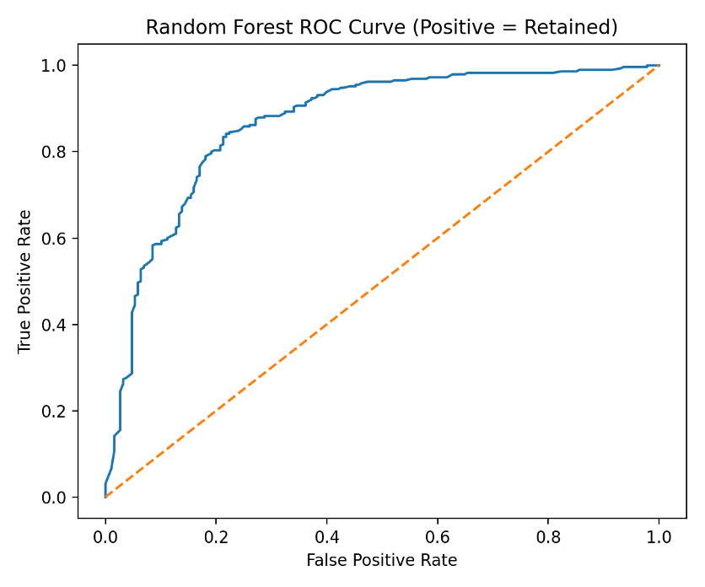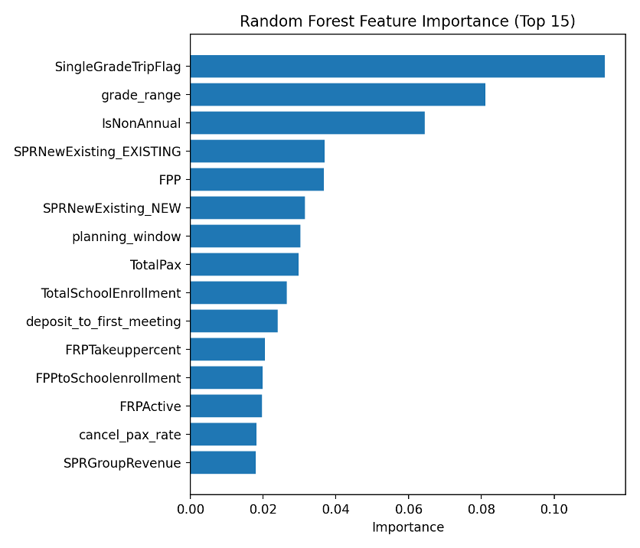

Key predictors (what drives predictions)
The most informative predictors (top 10 by feature importance) were:
· SingleGradeTripFlag
· grade_range
· IsNonAnnual
· SPRNewExisting_EXISTING
· FPP
· SPRNewExisting_NEW
· planning_window
· TotalPax
· TotalSchoolEnrollment
· deposit_to_first_meeting
Based on these predictors, practical recommendations include:
· Promote and support SingleGradeTripFlag trips (single-grade cohorts), since trip composition is strongly informative for retention.
· Track planning/lead-time indicators (e.g., planning_window, days_to_departure): customers with different planning behaviors may need different outreach timing.
· Monitor cancellation and discount behavior (cancel_pax_rate, discount_pax_rate) as potential early warning signals; intervene earlier with at-risk accounts.
· Use engagement proxies such as FPP and fpp_rate (fully paid participants) to prioritize retention efforts and forecast future churn risk.

New Model: Gaussian Process Classification
Gaussian Process Classification Introduction
We chose to learn about the Gaussian Process Classification (GPC) approach for our third model. Gaussian processes are a powerful machine learning method that uses prior knowledge to make predictions. They can be used for both regression and classification. Instead of choosing one single function to fit the data, they assign probabilities to many possible functions and use the most probable one as the prediction. This approach also provides a measure of confidence in each prediction.
A GPC builds upon this framework to predict class labels and provide probability estimates for those predictions. It assumes the existence of an underlying hidden function with a continuous output and uses a Gaussian process to model it. This hidden function is passed through a logistic function to turn its values into probabilities between 0 and 1. Because classification involves categories, the math becomes more complex, so the model uses an approximation method (the Laplace approximation) to determine which functions are now more likely given the observed data.

Feature Selection
For feature selection, wefirst examined the correlation between each feature and the outcome variable, RetainedLabel, and ranked them based on correlation and mutual information to identify the most influential variables. Wefocused on features such as days_to_departure, planning_window, meeting_span, IncomeLevel, TotalSchoolEnrollment, DepartureMonth, IsNonAnnual, Tuition, SingleGradeTripFlag, SPRNewExisting, FPP, and FRPActive. Wethen visually explored their relationships with RetainedLabel using bar plots, box plots, count plots, and histograms. Finally, we selected the final features by removing redundant variables, excluding categorical variables with too many categories, and prioritizing those with the strongest correlation and highest mutual information with the outcome.
GPC tends to work best with a small number of features rather than a very high-dimensional dataset. Because GPC relies on a kernel function to measure similarity between data points, too many irrelevant or noisy features can distort distance calculations and reduce model performance. Gaussian processes also require more computation as the number of predictors grows. As a result, GPC performs best when features are limited and carefully selected.
The final features we included in the model were the following:

planning_window  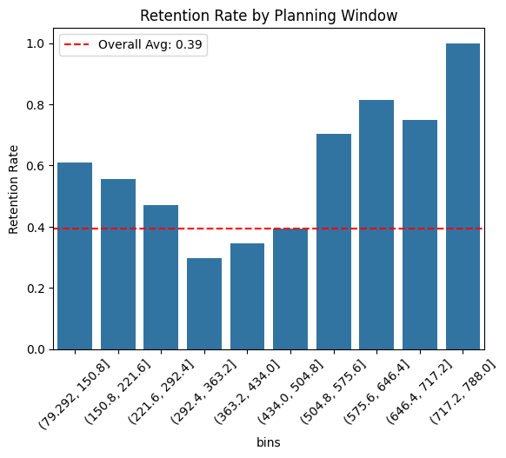 | TotalSchoolEnrollment  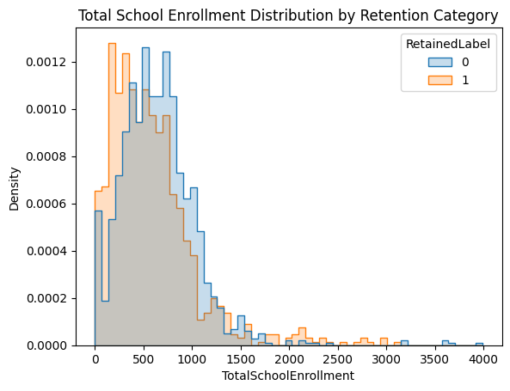 | DepartureMonth  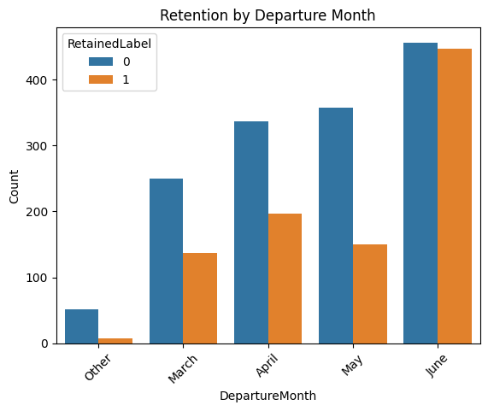
IsNonAnnual  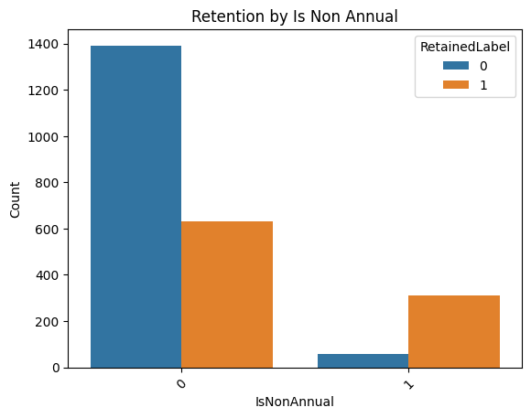 | Tuition  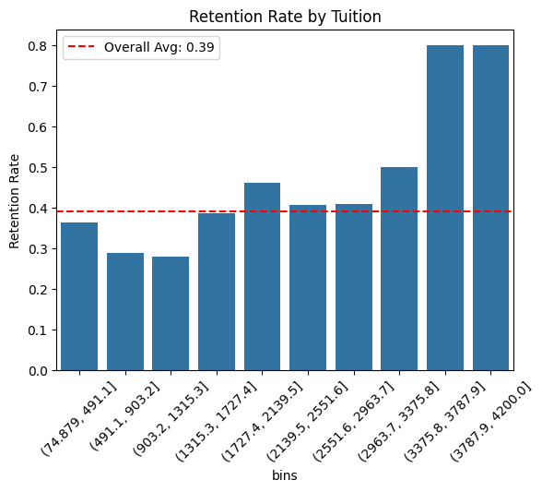 | SingleGradeTripFlag  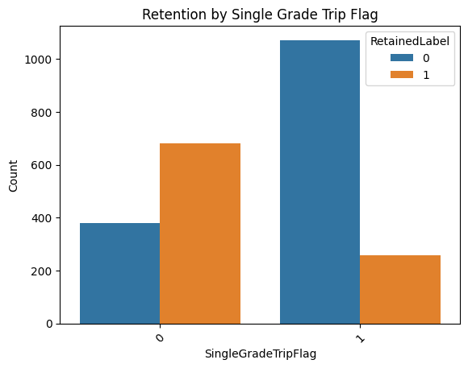
SPRNewExisting  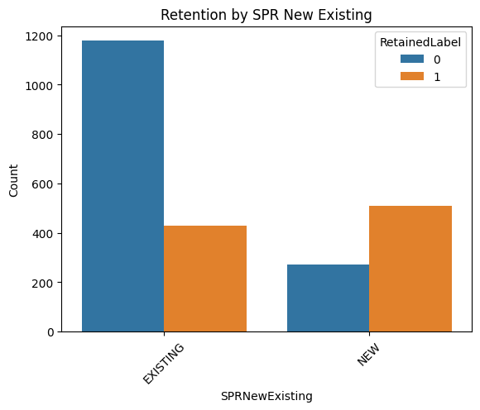 | FPP  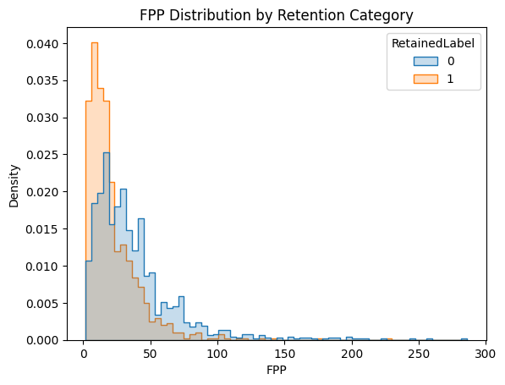

Hyperparameters Tuning
GPCs have a few key parameters. The kernel determines how the model measures similarity between points and captures patterns in the data, while its hyperparameters (such as length scale or nu) control the model's flexibility and smoothness. During training, the model automatically optimizes these kernel parameters to best fit the data. Another important parameter is n_restarts_optimizer, which specifies how many times the model retries this optimization.
To hypertune the GPC, wefirst split the data into training and test sets, limiting the training set to 1,000 observations to reduce computation time. We then ran a grid search testing different kernels—RBF, Matern (starting nu=1.5 and starting nu=5.5), and Rational Quadratic—and varied the number of optimizer restarts from 0 to 5. This allowed me to identify the hyperparameter combination that yielded the best performance. The best model used a Matern kernel with nu=1.5 and 0 optimizer restarts (meaning the model only optimizes once).
Best Model: (kernel: 1**2 * Matern(length_scale=1, nu=1.5), n_restarts_optimizer: 0)
Model Performance
We reset the data split so that 80% of the data was used for training and 20% for testing. After fitting the model on the new training set, we evaluated its performance on the test set by computing key metrics to assess how well it predicted the outcomes.
Metrics: (Accuracy=0.833, Precision=0.845, Recall=0.886, AUC= 0.888)

Model Comparison
The GPC was our best model. It had an 83.3% accuracy and 84.5% precision. It was the most reliable for identifying retained groups. The Random Forest reported 81.8% accuracy and a high recall of 87.9%. However, it produced more false positives than the GPC. This means the Random Forest was more likely to incorrectly predict that a group would return when they actually churned.

The KNN model was the weakest of the three. Even after tuning, its recall remained at 43%, and its primary issue was a high false-negative rate. Because recall measures a model's ability to identify all actual positive cases, this low score indicates that the KNN model failed to identify 57% of customers who actually returned. While the GPC and Random Forest successfully captured the vast majority of returning clients, the KNN model frequently overlooked them.

Model | Accuracy | Precision | Recall | AUC
KNN | 0.73 | .81 | .43 | .82
Random Forest | .82 | .83 | .88 | .87
GPC | 0.833 | 0.845 | 0.886 | 0.888

Recommendations
GPC Variance Importance Plot
Permutation importance works by randomly shuffling one feature at a time and measuring how much the model’s performance decreases. The importance score is based on the mean change in ROC AUC after each feature is shuffled.
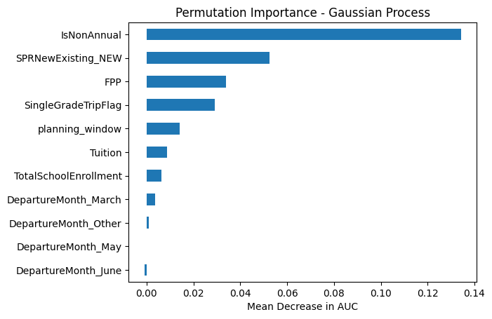
Using this information, we make the following recommendations:
- Maintain active relationships with "Non-Annual" schools during their off-years.
The models identified are.Non.Annual is a primary predictor of churn. By maintaining a relationship through educational content or early-planning resources during their gap year, we ensure STC remains the first choice when they are ready to travel again.

- Implement an early-warning system for the planning window.
The planning_window (the time between the Initial.System.Date and the Departure.Date) was a top predictor of chrun. Groups that start organizing earlier are much more likely to be retained. We should use the CRM to flag accounts that have missed their typical start date for immediate follow-up. A shrinking planning window is a high-risk indicator for churn, and early intervention can help get the recruitment process back on track.

- Design academically-relevant single-grade trips
The SingleGradeTripFlag was important in our model. We recommend designing trips with a single grade in mind, aligned with that grade’s curriculum, to enhance engagement. By tailoring the itinerary to a specific year's learning objectives, the trip becomes an essential part of the school's academic calendar, making it more likely to be retained as an annual tradition rather than a one-off event.

